**Foodar 100 - System Requirements Specification**

1. Description
2. Purpose
3. Scope
4. System Overview
5. Use Cases

**Description**

Foodar is a food delivery service application. Foodies will order take-out from a local restaurant, then use Foodar to find a Driver to pick up and deliver it to them. Delivery fees will be calculated based on distance driven, plus a base fee. Users must register a card to autopay drivers the approved amount.

User Roles:

1. Foodie: will create a delivery mission to pick up their food from a restaurant.
2. Driver: can accept delivery missions, and manage income.

Primary stakeholders have decided that Foodar users should have the ability to register to keep track of used services.

**Purpose**

The purpose of this document is to provide a guide for developers and testers who are responsible for the development of the platform. It provides the information necessary to design, develop, and test the software.

**Scope**

This document serves as a description of the required improvements to the project. It contains a workflow description, functional and nonfunctional requirements, and appropriate diagrams to fully describe the system.

**System Overview**

This enterprise project consists of one layer. The front-end is the one layer and is the portal through which users will interact with the application. Primary interactivity is achieved using JavaScript executing in the browser.

**Use Cases**

1. **All Users**
   1. **Request System**
      1. Create a request to find nearest driver
         1. algorithm should be clean
      2. Cancel a request
      3. Quote a request
         1. algorithm to generate price
            1. base price + request cost + driver fee + taxes
            2. need to generate tax table
      4. Track current time until receipt of food
   2. **Member System**
      1. Register a new member
      2. Sign-in a member
      3. Track requests

Use Case 0001 - Request System

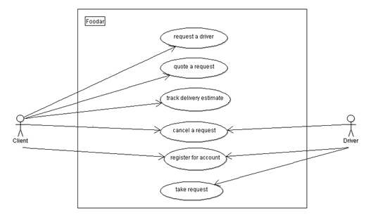

Use Case 0002 - Member System

